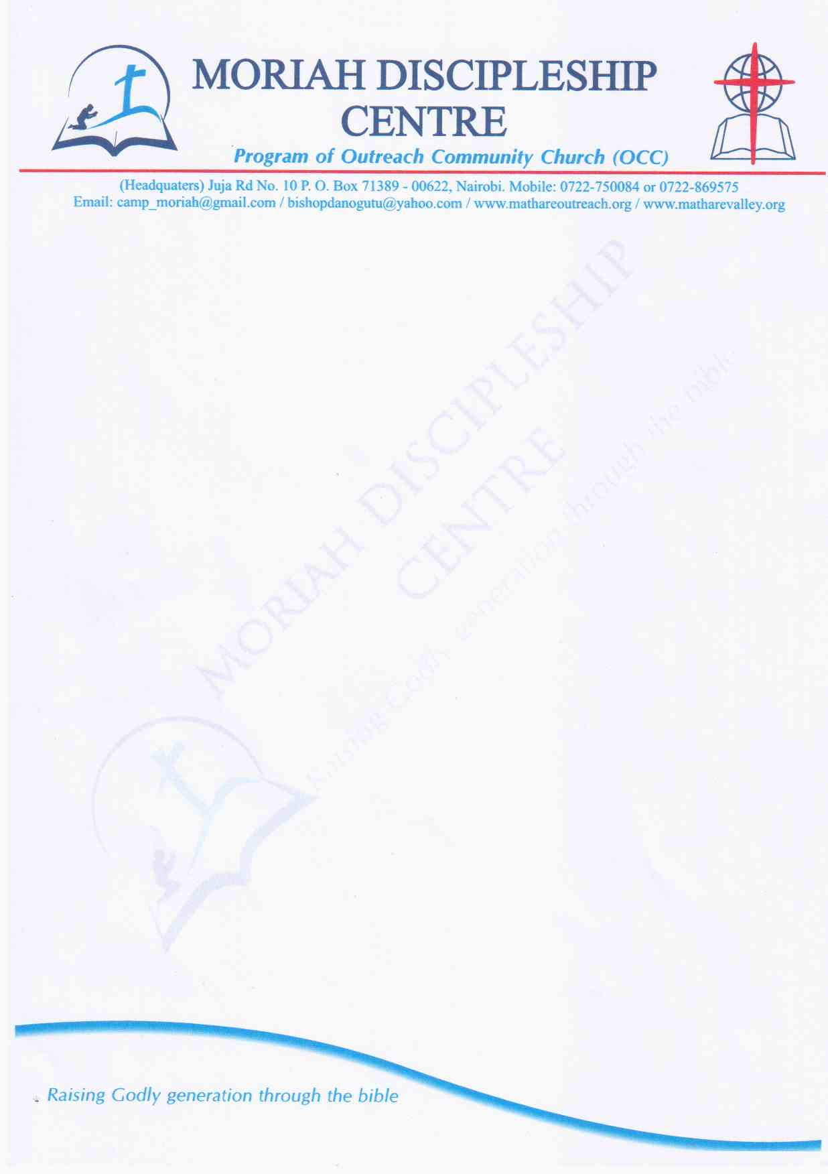

**MORIAH DISCIPLESHIP PROGRAM**

P.O. BOX 71389 00622 NAIROBI

*Email:* [*moriahdiscipleship@gmail.com*](mailto:moriahdiscipleship@gmail.com)*,*

*Tel: 0722750084 /0722869575/0726 041417*

Attach photo here

**Period of training: 6 months**

Commencement date: 12th January 2020

Graduation date: June

**Personal information:**

Name:………………………………………………………………………………………………………

Postal Address:……………………………………………………………………………………………………

Phone:……………………………………….Email:……………………………………………………….

Date of Birth:…………………………Gender:…………………….Marital Status:………………………

**Church:**

Name of your local church………………………………………………………………………………………………………..

Name of Pastor:…………………………………………………Phone No…………………………………

Pastor’s signature…………………………………………………………………………………………….

**Education:**

What is your highest level of education?.........................................................................................................

Hobbies and interests………………………………………………………………………………………...

**General health:**

Are you on special diet?........... (If yes explain)………………………………………………………………………………………………………………………………………………………………………………………………………………………..

**Family background.**

Name of Father:……………………………………………………………………Phone:…………………………

Name of Mother:…………………………………………………………………..Phone:…………………………

How many siblings do you have.....................................

**Parental consent:**

Name of person giving consent……………………………………………………………………………………………..

Relationship to applicant:………………………………

Signature………………………………………………..

**Fees.**

The total training fee per student is Ksh. 20,000. This caters for tuition, food, accommodation and other related expenses. The Fee can be paid in instalment of ksh 5,000 .Pay direct to account No 2028085276 Barclay Bank Kisumu branch Name Outreach community center –mco-cdc. No student will be admitted without paying a minimum of Ksh 5,000 during admission

*N/B****. Students will be required to take care of their medical expenses, personal effects and transport to and from the center****.*

**Admission process:**

Once this form is submitted, the student will be called for a brief interview. The admission is considered complete upon the payment of a commitment fee of Ksh. 1000 directly to the account or paybill No as may be provided

Should the parent/guardian or student have any question relating to the program, one is encouraged to enquire from the camp director or supervisors at MCO-OCC offices in Mathare Number 10.

Completed form to be returned by latest 3rd January 2020 at OCC No 10 Offices.

**Expectations**

During your stay in this program you will be expected to;

1. Dress appropriately and modestly ( low necked tops, tight or short skirts and tight trousers are not allowed)
2. Keep your rooms and bed areas clean, neat and orderly
3. Communicate and interact in a godly and responsible way using appropriate/wholesome language and respectful jokes/fun (indigenous/native languages are not encouraged in the program. All will use English or Kiswahili)
4. Be punctual for all activities and sessions-punctuality means making effort to be there five minutes before time
5. Complete all assignments given by your leaders either as individuals or groups
6. Show high submission to leadership/authority
7. Observe proper etiquette at all times and especially meal times
8. Socialize appropriately with the opposite sex
9. Be willing to assist in various tasks to make the program successful
10. Make effort to consult and to seek help/clarify from the leadership and within the team.

**OTHERS:**

* Students will make their own travel arrangements from their homes to training centre in Nyakach
* Carry personal effects e.g. soaps, tissue papers, blankets/bed sheets, toothpaste etc.
* Carry note books, bible a must (**NIV version recommended)** pens etc.
* Personal cloths including a track, rubbers/sport shoes. Girls are not allowed to wear trousers & Miniskirts in the training centre